SV15
Search with 1KHz freq bin, at the correct freq bin, max(abs(yy'))
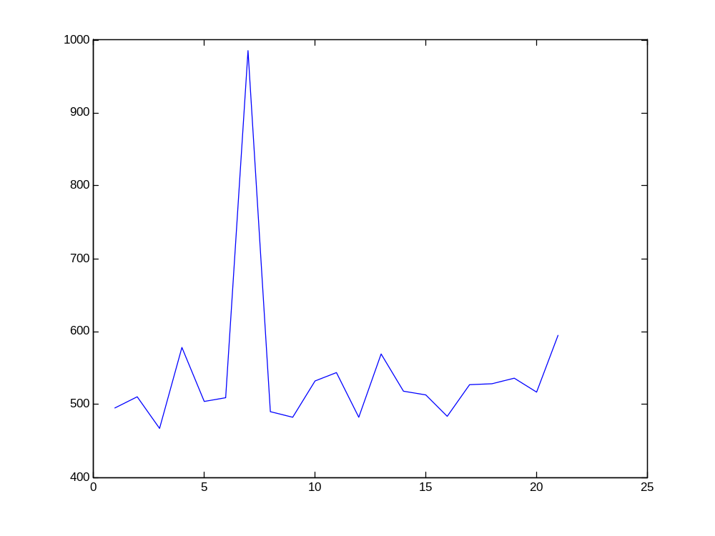
Fig 1 1KHz freq resolution, at the correct freq search point
We can see it is reliable to make a choice.
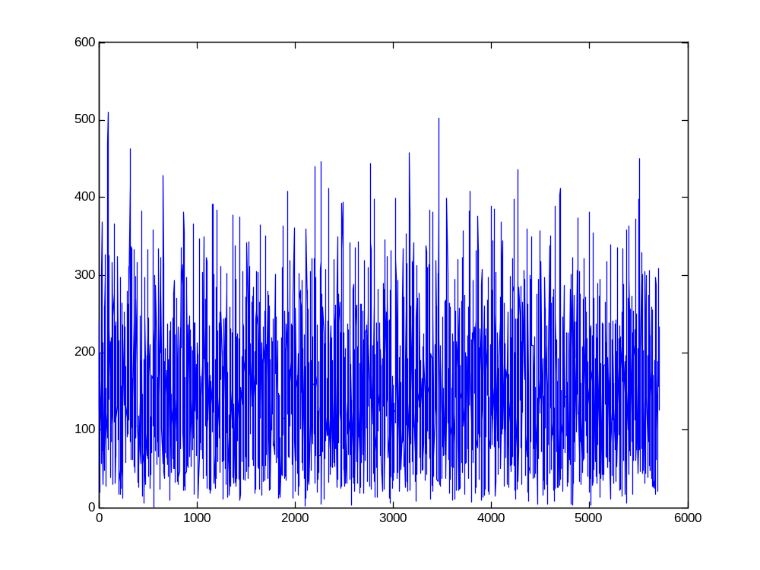
Fig 2 1KHz freq resolution, at correct freq search point -1KHz
We can see it is impossible to make a choice.

If we look into the detail of Fig 1, we can have:
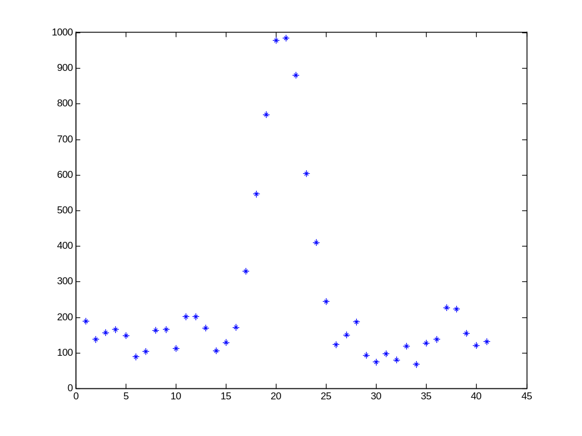
Fig 3 Details of 1KHz freq resolution search
There are about 11 points above the pseudo-noise level. Since sampling rate is 5.7MHz, 11 points lasts about 2 micro-second. 1micro-second CA chip period could be moved to the left and right by 1 micro-second and still has correlation.
If align the starting data point to be processed with the transition of CA code, we have:
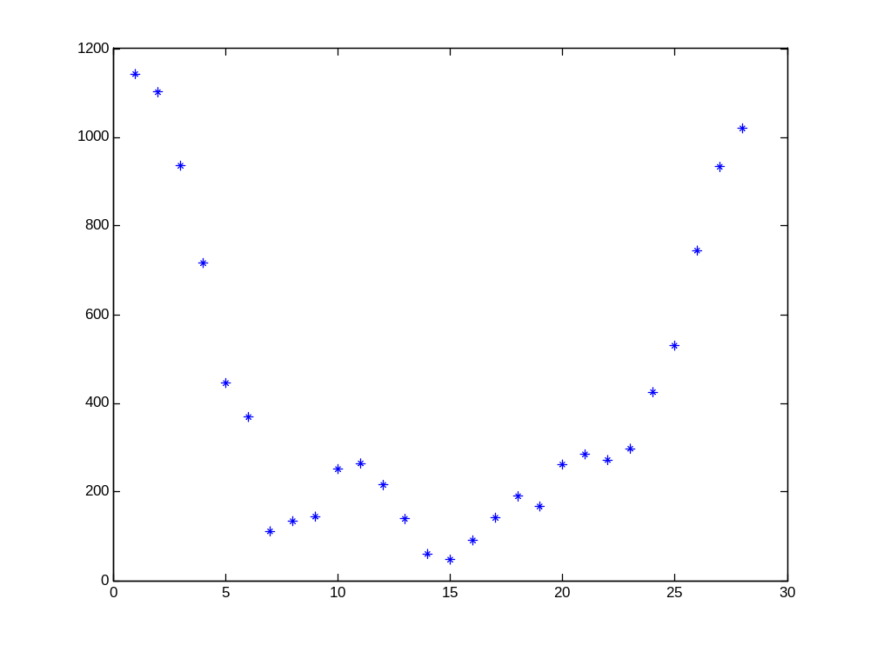
Fig 4 Aligned 1ms data after 1KHz resolution processing
We can see the correlation peak occurs at t=0, which is obviously to be correct.

[amp crw]=max(max(abs(yy')));
value of crw is 7.
The selection is obviously reliable.

Go for 400Hz resolution,
mfrq1(i)=abs(mfrq0(i))
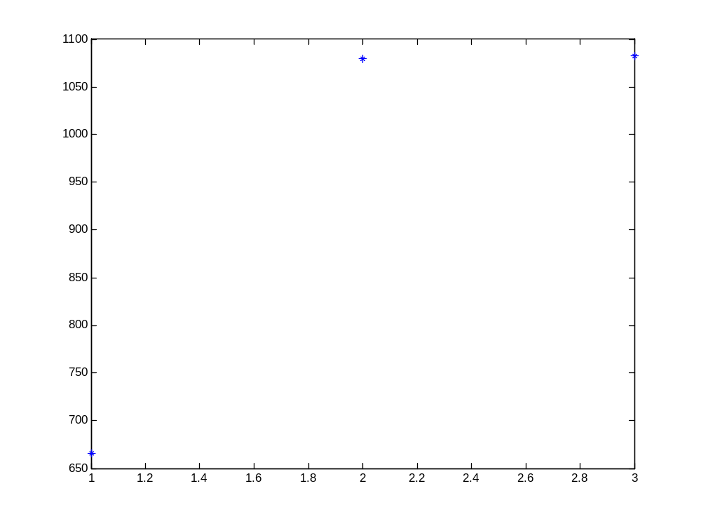
Fig 5 Why we cannot use 400Hz resolution
It is definitely not reliable to choose a point with greater value from the 2nd and 3rd points.
So, change the frequency search bin from 400Hz to 200Hz, and we get
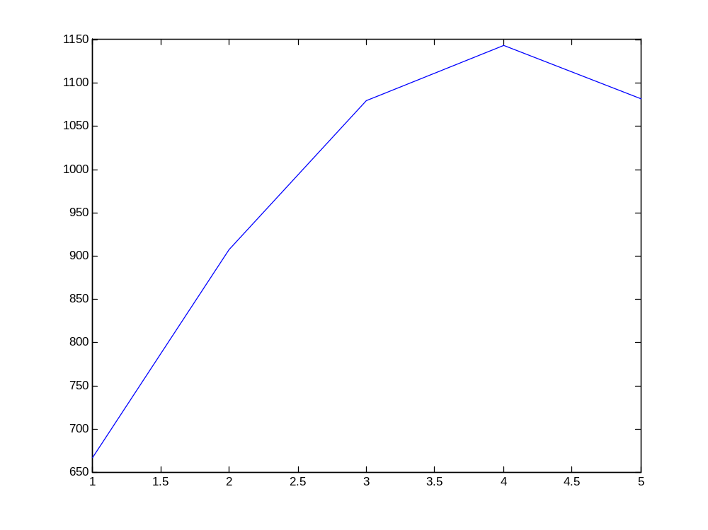
Fig 6 200Hz resolution is enough
Now it is reliable to make a right choice.

After going through fine freq tuning, we have the following fig with 15*6ms data.
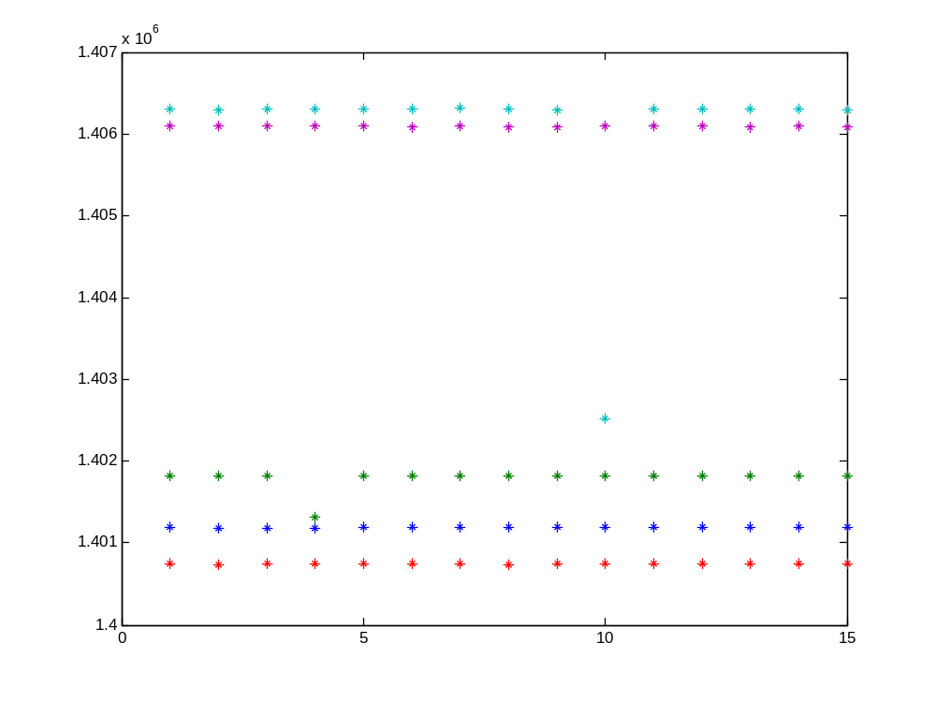
Fig 7 Freq estimate with error
Errors occur at 4th output for SV 18 and 10th output for SV 26.
First, analyze the mistake at the 10th output for SV 26.
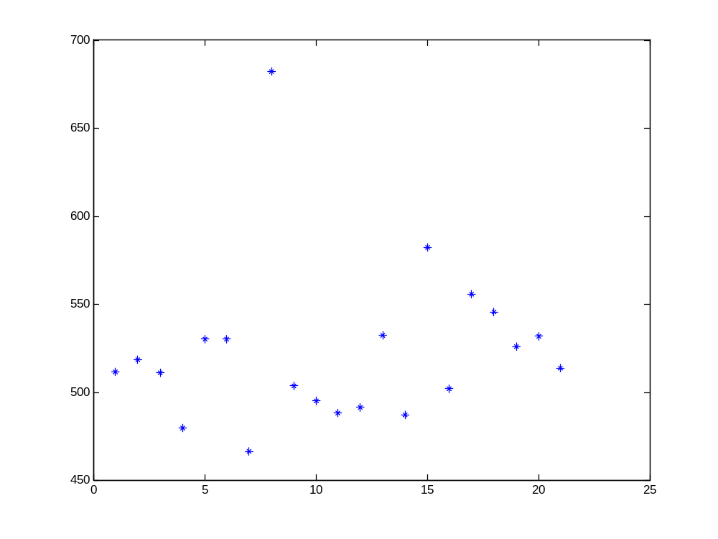
Fig 8 1KHz resolution plot for the 10th 6ms, set ms6=9
Compare with the following true estimate of freq bin, we see erroneous freq bin estimate occurs here.
In the 9th 6ms data, the 1 KHz resolution plot is shown as follows:
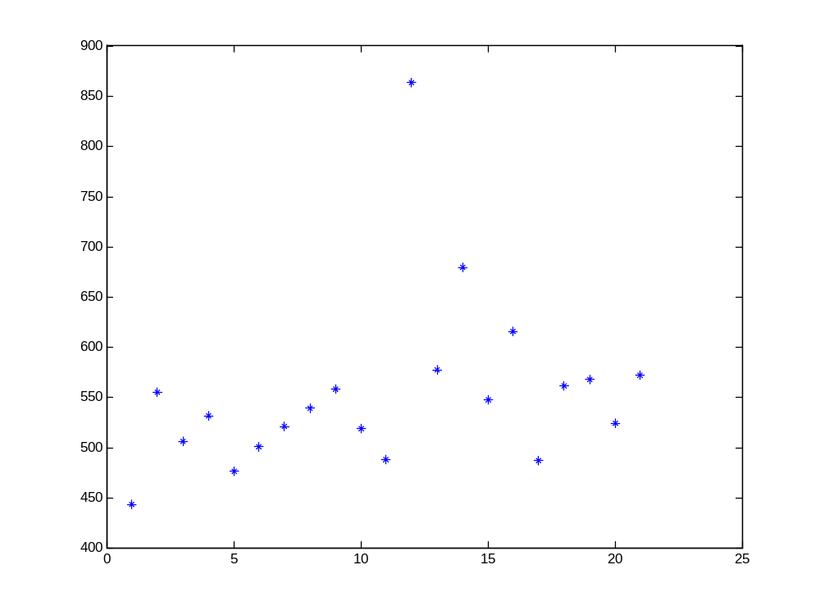
Fig 9
In the 11th 6ms data, the 1KHz resolution plot is shown as follows:
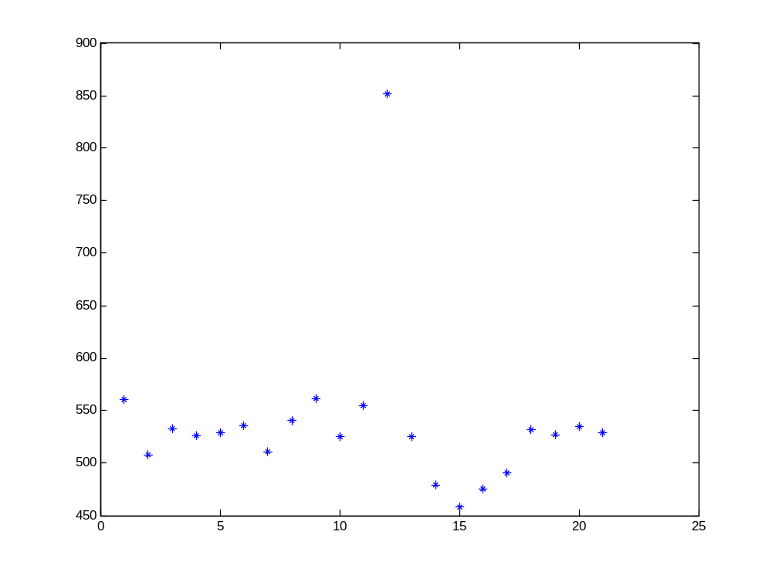
Fig 10
As we can see from Fig 9 and Fig 10, the frequency estimations are both located at the same freq bin, which is far from that in Fig 8.

Go further, since the 1KHz estimate is conducted using 1ms data only, we use the input data 1 ms later, and we have the correct plot again:
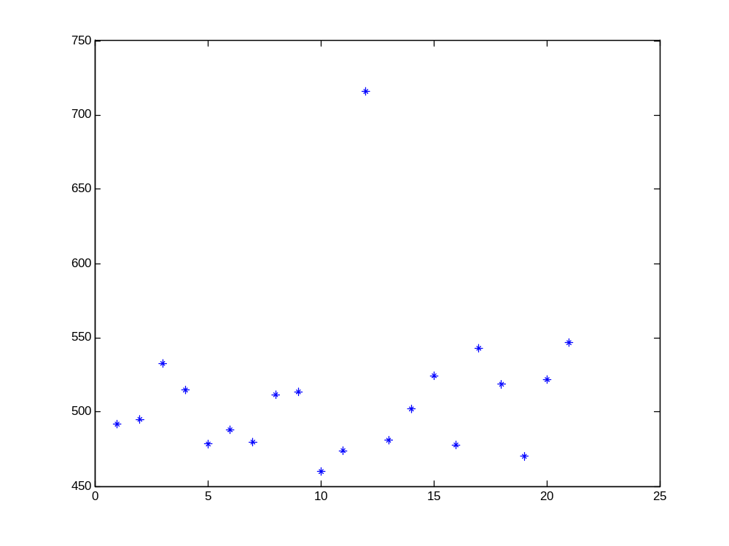
Fig 11
use the input data 1 ms earlier, and we have the correct plot again:
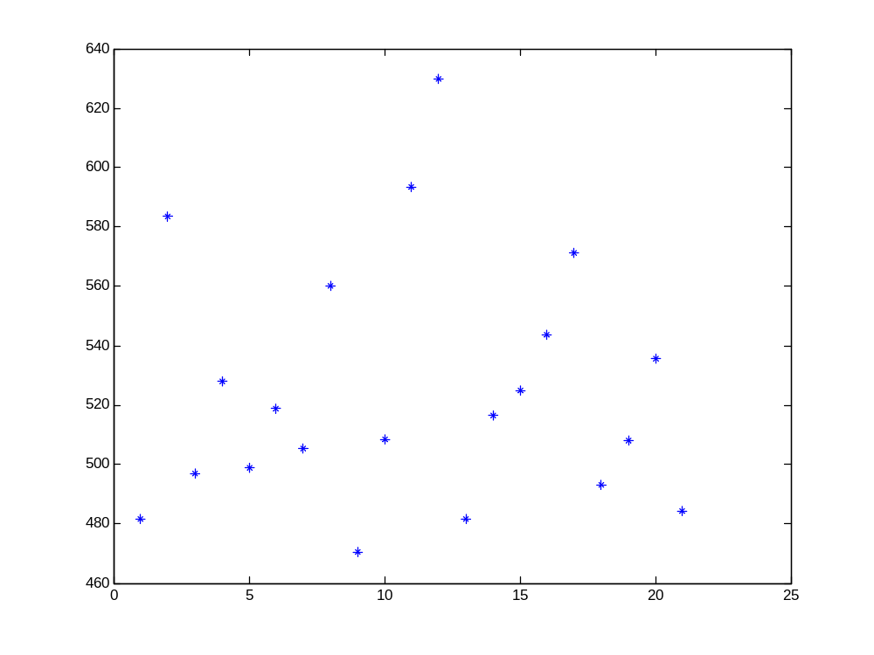
Fig 12
Compare the No.8 output and N0.12 output, it is not so good, but it is still acceptable.
use the input data 2 ms earlier, and we have the correct plot again:
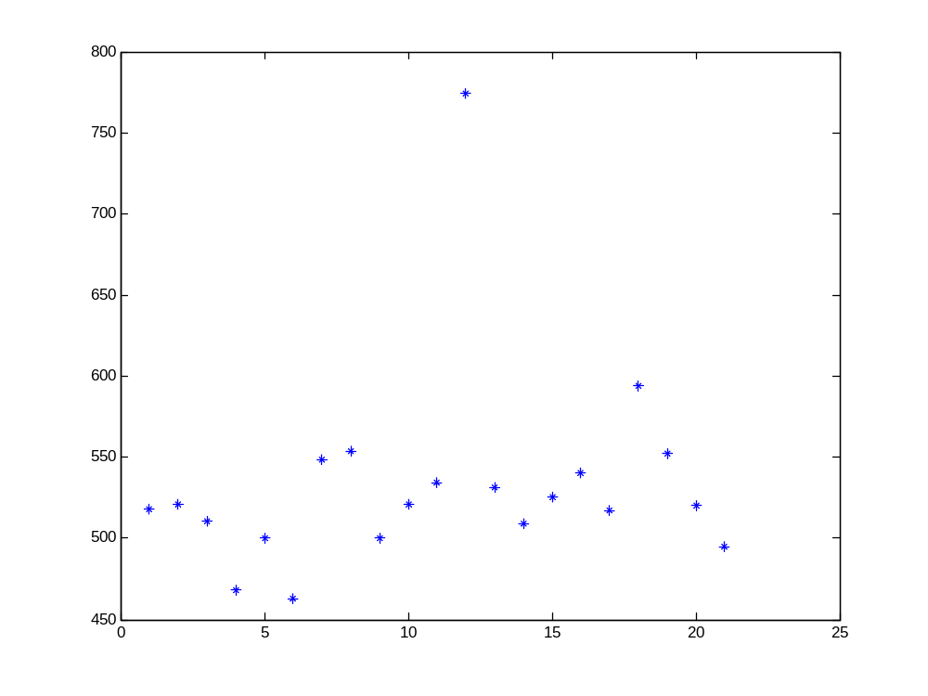
Fig 13
Compare the No.8 output and N0.12 output, it is perfect again.
For the time being, I cannot figure out its causes.
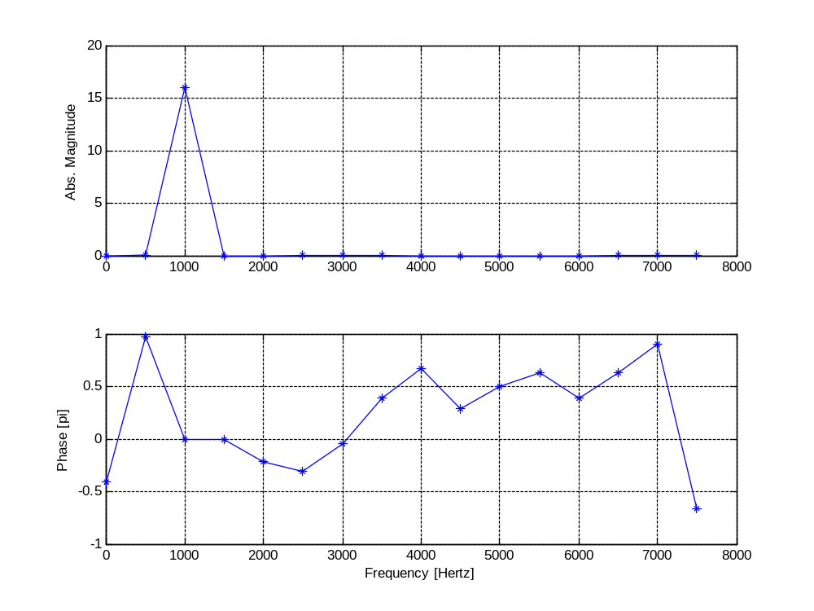
startingtime = 0; % 2pi cycle counter
datalen = 2; % 2pi cycle counter

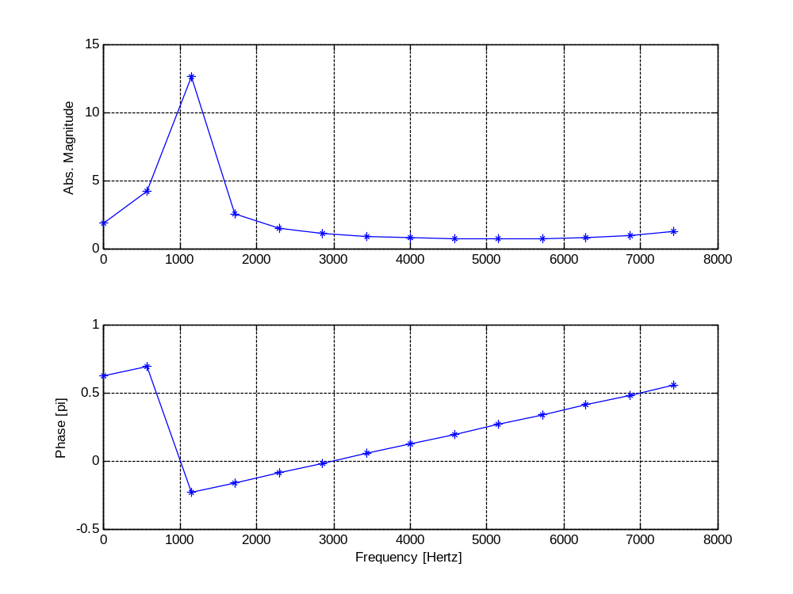
startingtime = 0; % 2pi cycle counter
datalen = 1.75; % 2pi cycle counter

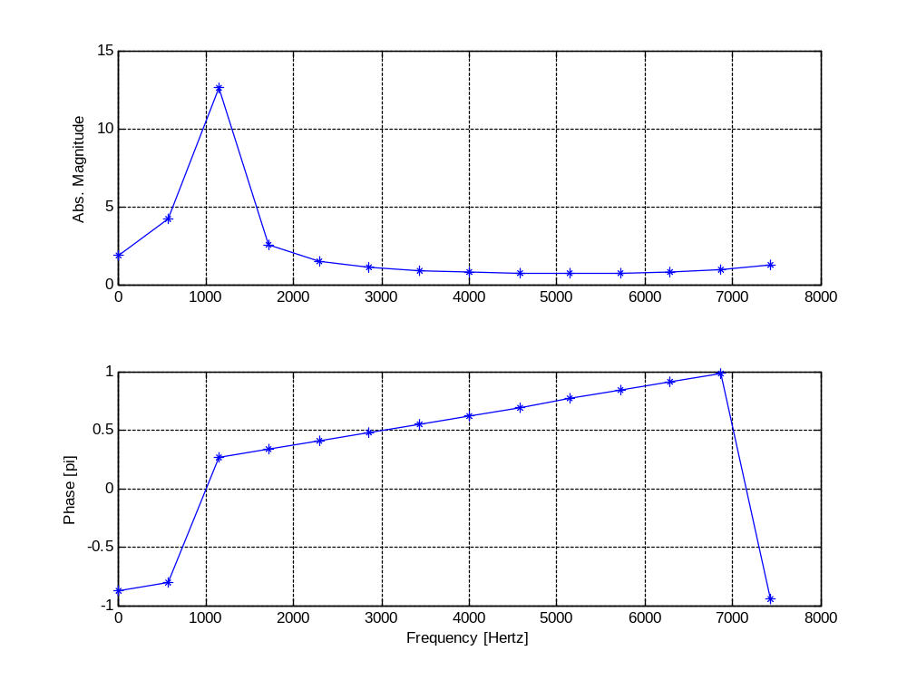
startingtime = 0.25; % 2pi cycle counter
datalen = 1.75; % 2pi cycle counter

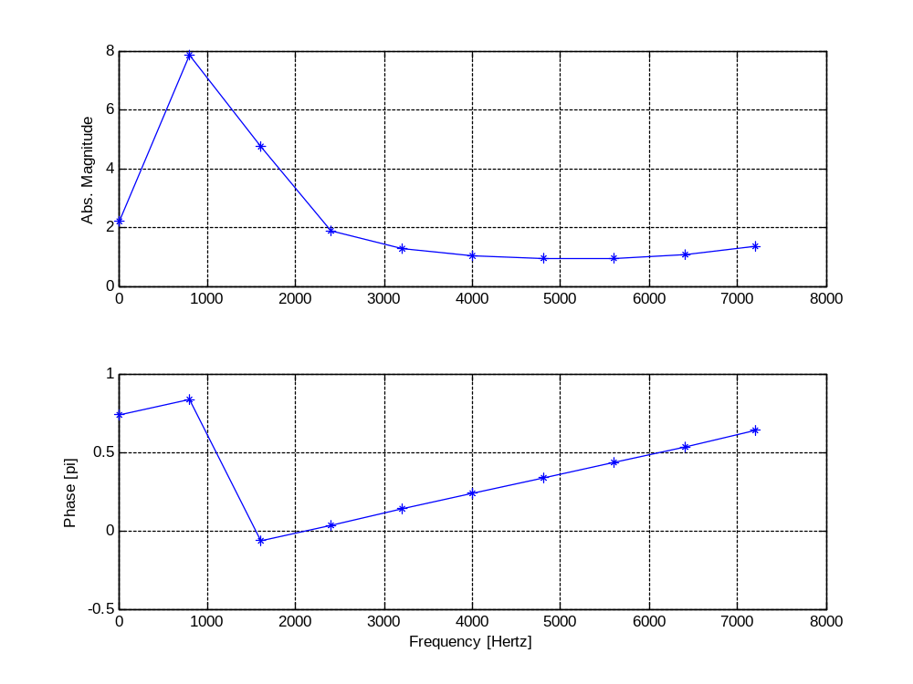
fc=1100; % center freq
fs=8000;% sampling freq
startingtime = 0.25; % 2pi cycle counter
datalen = 1.5; % 2pi cycle counter

Start phase | Fractional End phase | fft phase
0 | 2π | 0
0 | 1.8π | -0.1π
0 | 1.5π | -0.25π
0 | 1.2π | -0.4π
0 | π | 0.5π
0 | 0.8π | 0.4π
0 | 0.5π | 0.25π
0 | 0.2π | 0.1π
0.2π | 2π | 0.2π
0.5π | 2π | 0.5π
0.8π | 2π | 0.8π
π | 2π | π
1.2π | 2π | - 0.8π
1.5π | 2π | - 0.5π
1.8π | 2π | - 0.2π
0.2π | 1.8π | 0.1π
0.5π | 1.5π | 0.25π
0.8π | 1.2π | 0.4π
π | π | -0.5π
1.2π | 0.8π | -0.4π
1.5π | 0.5π | -0.25π
1.8π | 0.2π | -0.1π

fft phase  change start phase | fft phase  change end phase | fft phase  change both
-0.1π | 0.2π | 0.1π
-0.25π | 0.5π | 0.25π
-0.4π | 0.8π | 0.4π
0.5π | π | -0.5π
0.4π | - 0.8π | -0.4π
0.25π | - 0.5π | -0.25π
0.1π | - 0.2π | -0.1π
After taking 2πcycle period into consideration, we find:
Column3 = Column1 + Column2

VeryFirstSample = 5714*6*passed6ms + all_ccn(temp(1),SVindex)
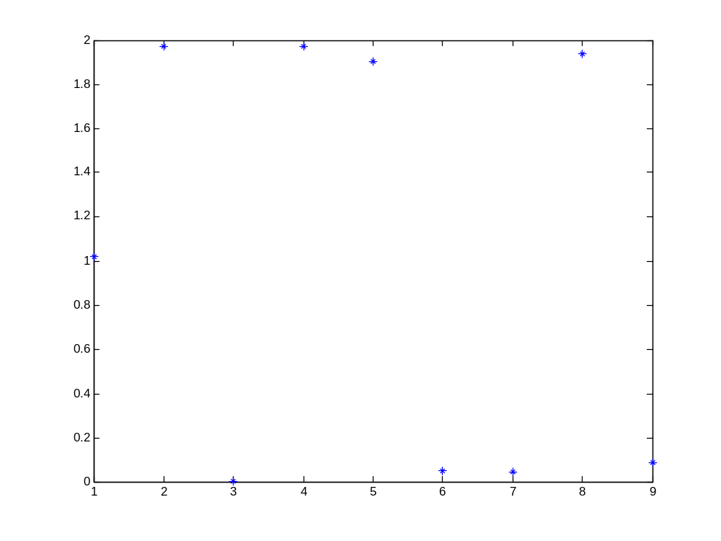
VeryFirstSample = 5714*6*passed6ms + all_ccn(temp(1),SVindex)+6;
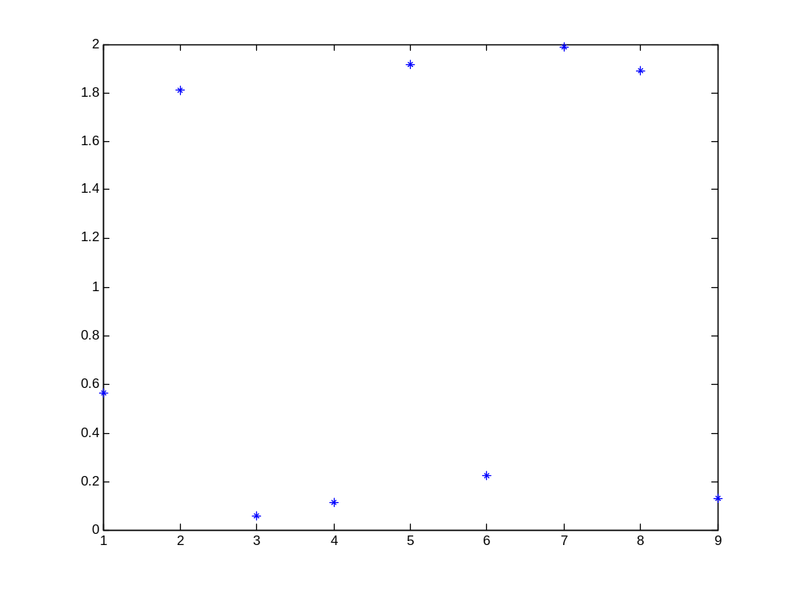
VeryFirstSample = 5714*6*passed6ms + all_ccn(temp(1),SVindex)+7;
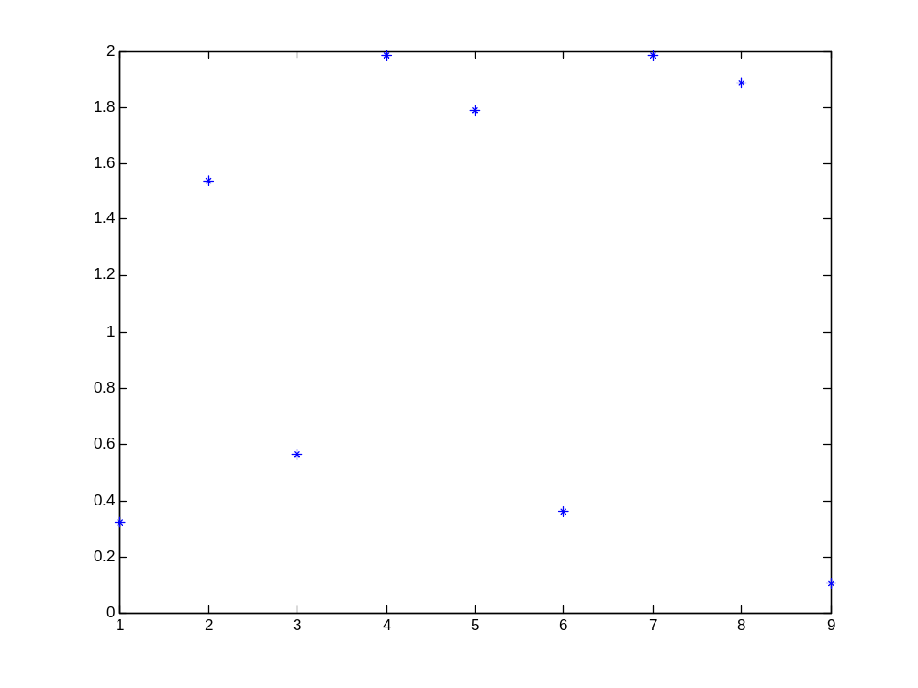
VeryFirstSample = 5714*6*passed6ms + all_ccn(temp(1),SVindex)+8;
